Gastrells Community Primary School

Kingscourt Lane, Stroud, Gloucestershire GL5 3PS
Telephone 01453 765959
Interim Executive Head Teacher: Gary J Price
Deputy Headteacher: Mr Alex Brown
www.gastrellsprimaryschool.co.uk admin@gastrells.gloucs.sch.uk
15 January 2026
Bikeability: Week beginning Monday 2nd February 2026

Dear Parents and Carers

As part of our PE and personal development provision at Gastrells, Year 5 pupils will have the opportunity to take part in the Bikeability cycling and road safety programme. This is an important life skill as well as an enjoyable learning experience.
The training will take place both on the school site and on public roads. Further information can be found in the attached document.

Equipment required:
• A bike with working brakes and gears (bikes may be stored at school for the week if helpful)
• A helmet
• Weather-appropriate clothing, including gloves

The course will not run continuously throughout the week. Instead, pupils will be allocated specific tuition slots, which will be agreed with the instructors at the start of the week. To ensure your child does not miss their first session, please bring their bike into school on Monday.

Thanks to a subsidy from Active England, we ask for a contribution of £10.00 per child towards the cost of the training. Please make payment via School Money.

The first part of the course will take place on the school site. During this session, instructors will assess whether pupils are able to safely control their bike before progressing to the on-road element. Please note that this is a professional judgement and, unfortunately, no refund can be offered if a pupil does not meet the required standard.

To secure your child’s place, please fill in the form via the link below. This must be completed before your child can take part in the course.

Bikeability Permissions form Feb 26 – Prefilled form

Thank you for your support.

Many Thanks




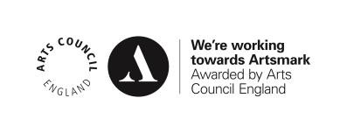
Mr Lowe

