

A flying start to a life of learning

SUMMER TERM INFORMATION

Dear Owls class parents/carers,

A very warm welcome back to you all as we begin our Summer Term. We hope you had a lovely Easter break and are feeling refreshed for the exciting weeks ahead. We have a busy and enjoyable term planned, with lots for the children to look forward to. This term we will be jetting off to space to learn a little bit more about the world around us and after half term, we will explore a little bit closer to home by learning all about the animals and their habitats. Alongside all the learning and class activities, there are several special events coming up, including Sports Day and a class trip. We are sure these will be wonderful opportunities for the children to have fun, build confidence, and create lasting memories. Please find below some information about the term ahead:

Morning Arrival
Please ensure that your children arrive promptly at 8.45am as retrieval tasks are set for the initial 15 minutes of each day to support consolidation of learning. In order to support your child's independence and prepare them for Year 1, please can we encourage them to leave you at the play garden gate and walk into school independently.

Lunch
Please remember to pre-order your child’s hot dinner via ParentPay. Should you forget to order a lunch in time, please contact the main office at your earliest opportunity.

Forest School
We are very lucky to be able to continue to access forest school this term and this will be changing time this term to every Monday morning. Thank you to everyone that has managed to find time to come and help last term. We really appreciated all your help! If you can, please let me know if you can come and help this term too!

PE
This term we will be having two PE sessions on both Thursday and Friday so please send your child in ready for PE on these days!

Mystery Reader
We have all been absolutely loving our Mystery Readers and thank you to everyone who has managed to come and read! We would sitll love any volunteers. If you’d like to come and read a story to the class, please let me know!

Tapestry
Don’t forget to check Tapestry for weekly updates on phonics and our classroom learning. Please use the photos to support your child’s learning by talking with them about what they’ve been doing at school.

I can’t wait for another fantastic term!

Warm wishes,
Miss Woolls
Take a look at our learning for the term below.
Communication and Language | Children communicate their ideas clearly, taking part in back-and-forth conversations.  Children can explain and describe their ideas using full sentences.  Children are attentive listeners and can respond to a story or comment with relevant information.  Children use new and interesting vocabulary with confidence and in the correct context.
PSED | Children demonstrate understanding of their own feelings and the feelings of others.  Children show perseverance and resilience when problem solving.  Children can play cooperatively with their peers.
Literacy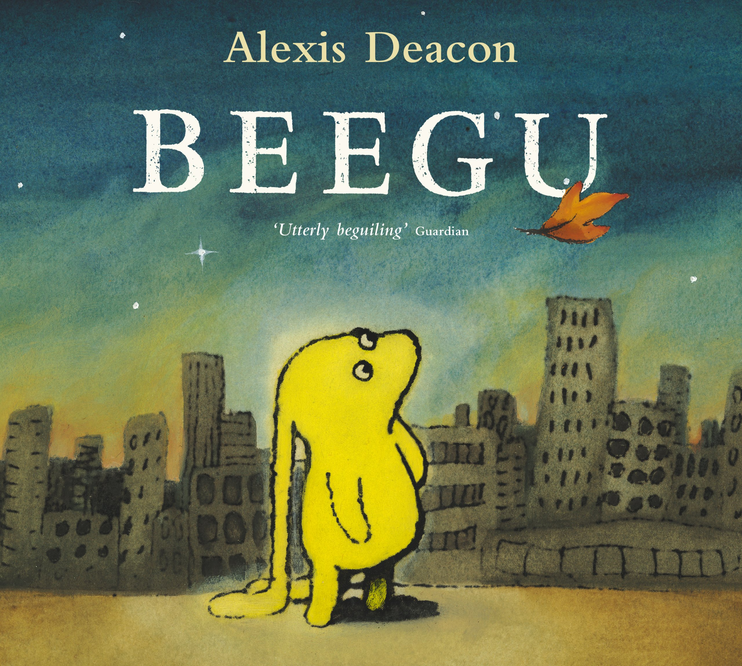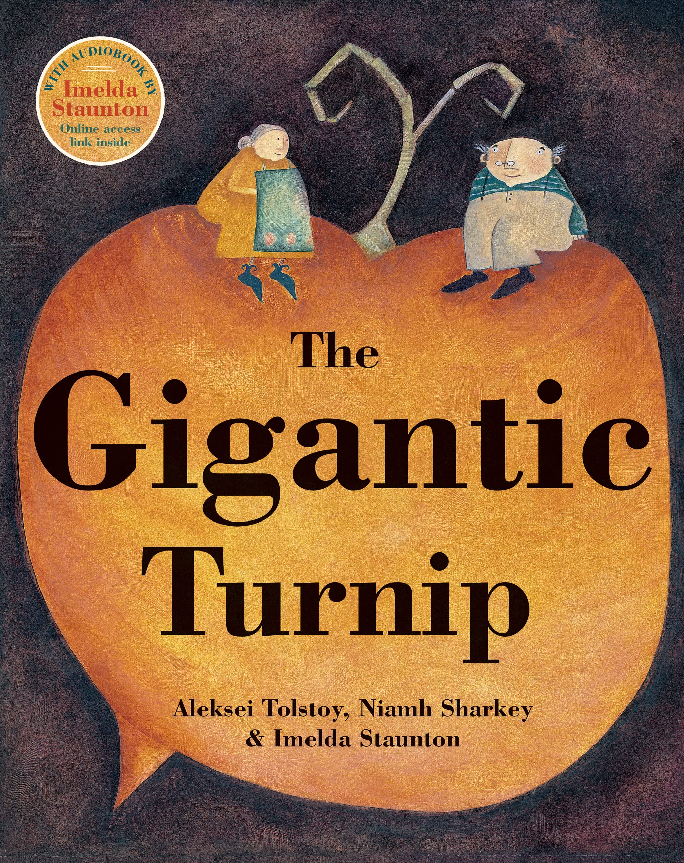 | Children can read and write simple words and sentences, consistent with their phonics knowledge.  Children can re-read their own writing.  Children use finger spaces, capital letters, and full stops more consistently.  I can write most upper and lower-case letters correctly  I can explain what I have read or has been read to me  I can say what I think might happen next  I can use new vocabulary throughout my play  Little Wandle – Summer Term – Phase 4 - We will be learning consonant blends and reading longer words. Find more Weekly Phonics updates on Tapestry.
Maths  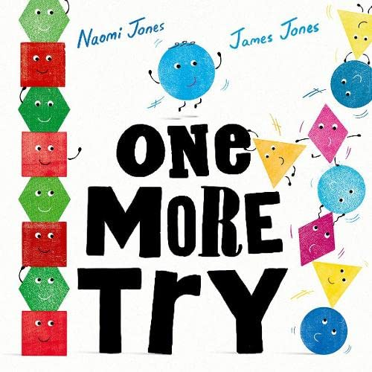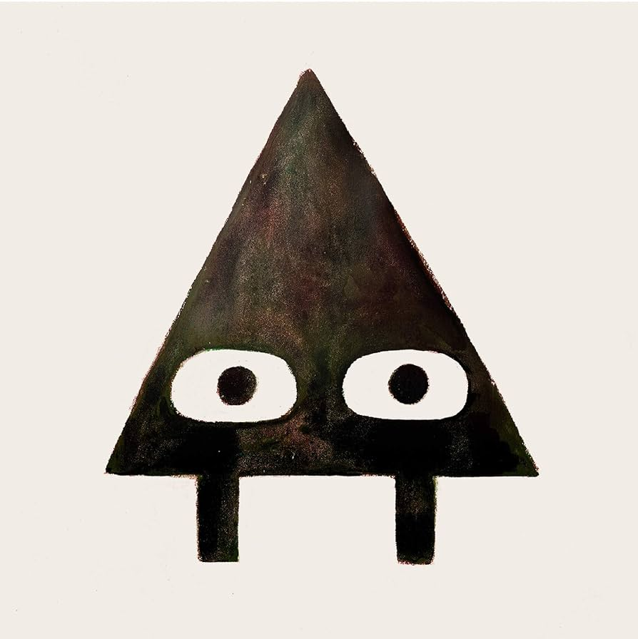 | I can recognise the numerals to 10 and match to quantity consistently  I can recognise quantities up to 5 without counting  I can recall number bonds up to 5 and some to 10 and start to match some subtraction facts.  I can recall some double facts within 10  I can compare quantities using greater/more than, fewer/ less than, the same/equal  I can show how numbers to 10 are made up using different models e.g. part, part, whole, tens frame.  I can count beyond 20  I can talk about odd and even numbers  I can say double facts  I can share equally
PE  (Gross and Fine Motor) | Athletics  Handwriting – Lower Case & Upper Case.
Understanding the World | Children compare similarities and differences between the past and present.  Children can talk about what plants need to grow.  Children will show care for the natural world around them.
Expressive Arts and Design | Children can talk about their creations, explaining the process the choices they made.  Children will perform familiar songs to their peers.  Children incorporate storylines into their play with their peers.  Children choose and use colours accurately.

