
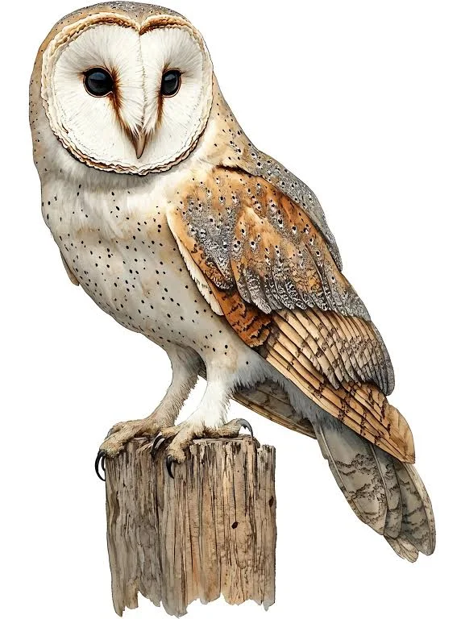

A flying start to a life of learning

AUTUMN TERM INFORMATION

Dear Owls class parents/carers,
We would like to take this opportunity to give a very warm welcome to all of our children and families in Owls Class. It is lovely to welcome back some familiar faces for another year in Owls, as well as welcoming those children who are joining us for the first time.
We are so excited to be teaching your children and getting to know them even more throughout the year. We have lots of exciting learning, fun experiences and adventures planned, and we are really looking forward to a happy and wonderful year together!
This year, the Owls Class teacher will be Miss Woolls, with Mrs Peach covering every Tuesday morning. We will also be supported by our wonderful class teaching assistants, Mrs Riley, Mrs O’Brien, Mr Ghulam and Mrs Cook, throughout the week.
The following information will provide a deeper insight into the term ahead, as well as a reminder of our Gastrells ethos, which is built around the core values of PRIDE, underpinning all aspects of our academic, social and emotional curriculum.
We are looking forward to a fantastic year together!
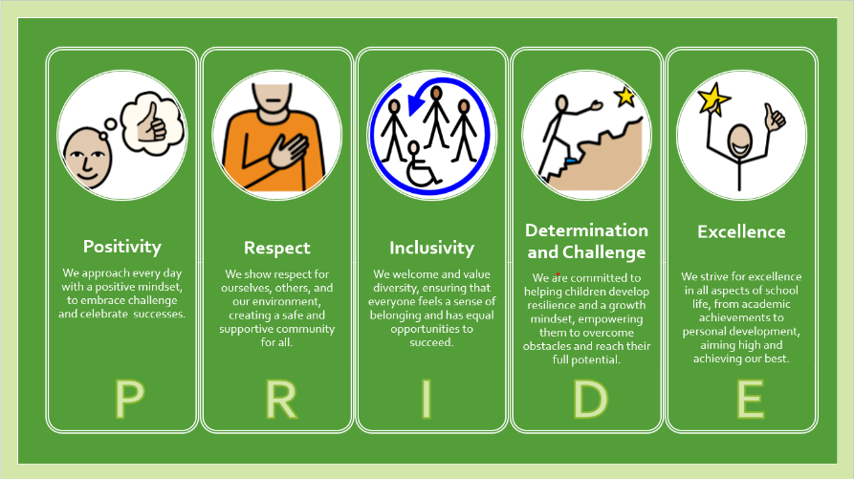

Warm wishes,
Miss Woolls

Morning Arrival  Please ensure that your child arrives at 8:45am promptly. In Owls, we aim for all children to come into school independently in the mornings, so please help us by encouraging this at home. The children will all have a morning task to complete, so it is important that they arrive at school on time.  Communication  My door is always open should you need to have a chat about anything or ask any questions throughout the year. I will happily put your mind at ease about anything you are unsure of or any concerns that you may have, so please don’t hesitate to ask.  Reception and Year 1 will continue to use Tapestry to document their learning throughout the week. You can also share any achievements or adventures you have enjoyed at home with us through Tapestry.  Snack  At snack time, we offer the children a choice of fruit or vegetables, alongside cow’s milk or water. Your child is welcome to bring in their own snack if they would prefer, but please ensure that this is a healthy snack.  If you would like your child to have milk at school, please register through the Cool Milk website. This is free for children under 5.  https://coolmilk.com/parents/  Independence  One of our priorities in Owls is developing your child’s independence, and we would love your support with this at home. This could include tasks such as walking into school independently, dressing themselves or using the toilet independently.  This term, we would particularly love it if your child could learn how to put their coat on independently. This will help them massively as we progress into the colder and wetter months! | Lost Property  Please can you ensure that you name everything! We have already had multiple lost jumpers, cardigans and water bottles. We want to help keep your child’s belongings safe and return them to them each day, so please label everything clearly to make this easy for everyone.  PE  We will be having PE lessons on Tuesdays, so please ensure that your child comes to school in their PE kit on these days. This should consist of a plain black top and black shorts or joggers. Your child should also have Velcro trainers that they can put on independently.  Phonics and Reading  One of the most important areas in both EYFS and Year 1 is developing early reading skills. We have already begun our phonics learning in Reception and will be learning our initial sounds next week!  Please familiarise yourself with these sounds at home too. You can find them on the school website or through Little Wandle:  https://www.littlewandle.org.uk/resources/for-parents/  We will be reading with your child three times a week in school. Each session will focus on a different element of reading: decoding, prosody and comprehension. Your child will then bring their reading book home on a Friday to ‘show off’ their reading to you over the weekend.  Look out for more information soon about reading books and our phonics meeting, where we will share lots of tips and tricks to help you support your child’s reading journey and, most importantly, develop a love of reading.  Forest School  Reception/Year1 will be in Term 3, dates will be sent out nearer the time

Our learning this term:
Personal, Social and Emotional | PSHE | Zones of Regulation  Me and My Relationships
Communication and Language |  | Reception: Sharing Ideas, Simple conversations, exploring vocabulary, following simple instructions
Literacy | Writing | Reception: Letter formation, Mark Making, Name Writing, CVC words.  Year 1: Letter formation, Simple sentences, Punctuation and retelling traditional/familiar tales.
 | Reading (Phonics) | Reception – Little Wandle – Phase 2 (see below)  Year 1 – Little Wandle – Phase 5 (see below)
 | Maths | Number, Place Value, Geometry, Addition and Subtraction within 10.
 | PE | Gymnastics & Invasion Games  (Tuesday & throughout continuous provision)
Expressive Arts and Design | Art | Spirals, Self Portraits, Colour Mixing, Clay  Artist: Yayoi Kusama
Expressive Arts and Design | Design and Technology | Lantern Making  Mechanisms: Making a moving story book.
Expressive Arts and Design | Computing | Computer Systems and networks: Improving Mouse Skills
 | Music | Practicing the Nativity Songs & Performing  Nursery Rhymes
 | PSHE | Zones of Regulation  Me and My Relationships
Understanding the World | Humanities | History - How am I making history?  Geography - What is it like here?  RE - What do Christians believe God is like?
Understanding the World | Science | Seasonal Changes
